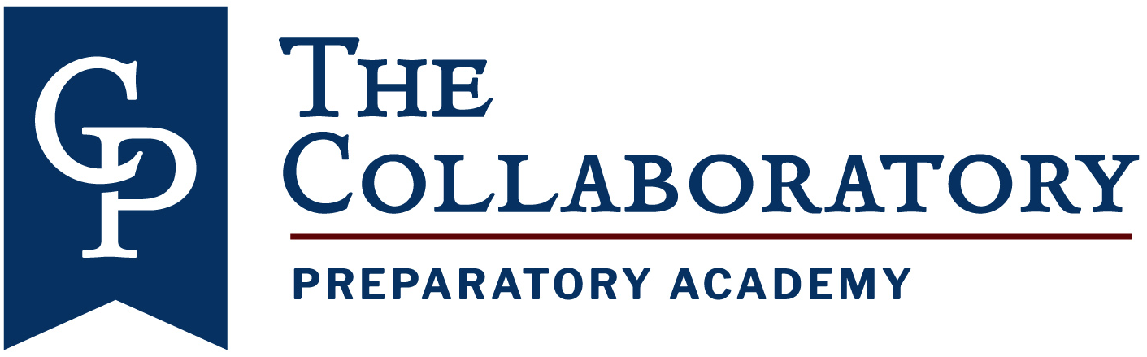

Sept 18, 2025

Collaboratory Prep 2025-2025 Board Meeting Schedule

Q1 Board Meeting: October 15, 2025. Time TBD.

Q2 Board Meeting: December 17, 2025. Time TBD.

Q3 Board Meeting: February 18, 2026. Time TBD.

Q4 Board Meeting: May 13, 2026. Time TBD.